1. **Command** 🡺 docker ps 🡸 Will list all the different running containers on our machine.
2. 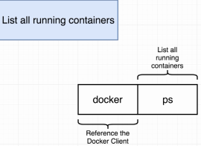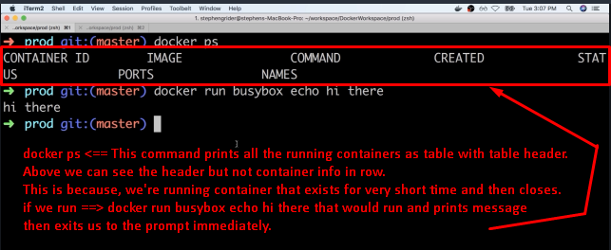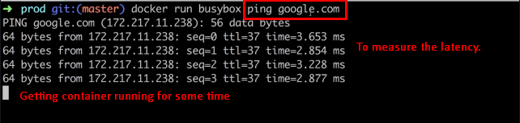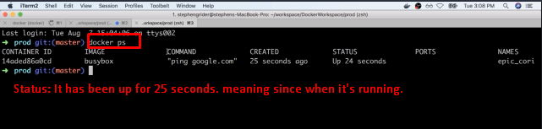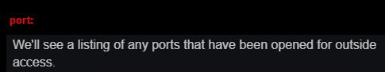
3. 